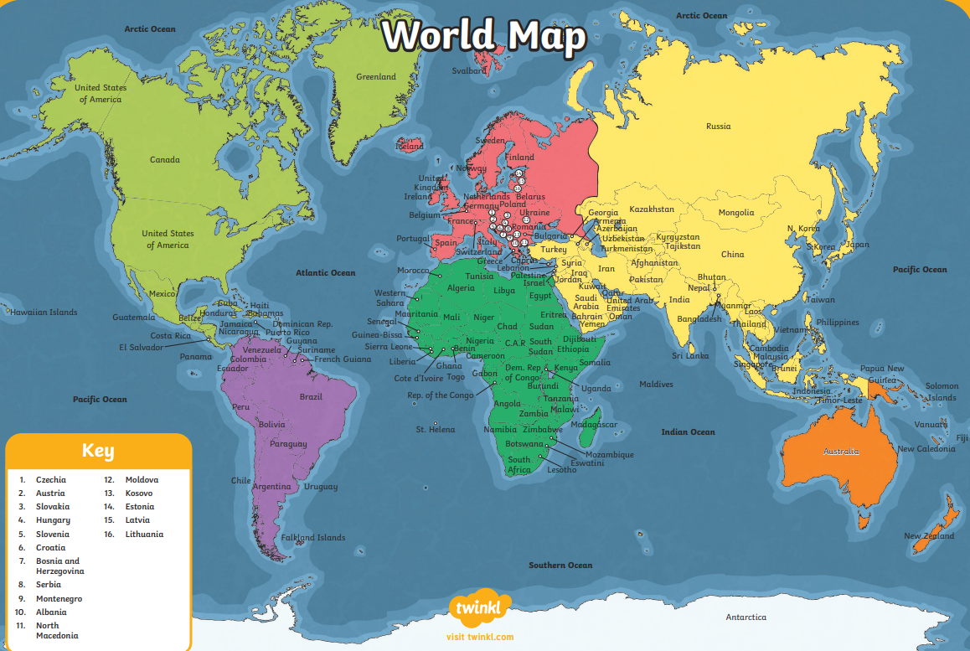

Capitals of Culture
What is a capital city?
- The city where the government of that country is based.
- Usually has important buildings like parliaments and highest courts of justice.

Lines of latitude and longitude
are used to locate places accurately
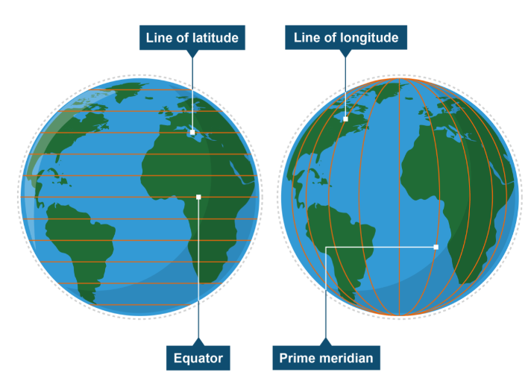
on the Earth’s surface.
Physical geographical features – natural features on the Earth’s surface (examples – rivers, mountains).

Human geographical features – things that have been created by people (examples – pyramids, bridges).
Buenos Aires – Argentina
Cairo – Egypt
Moscow – Russia
New Delhi – India
Sydney – Australia
Tokyo – Japan
Washington DC – USA

