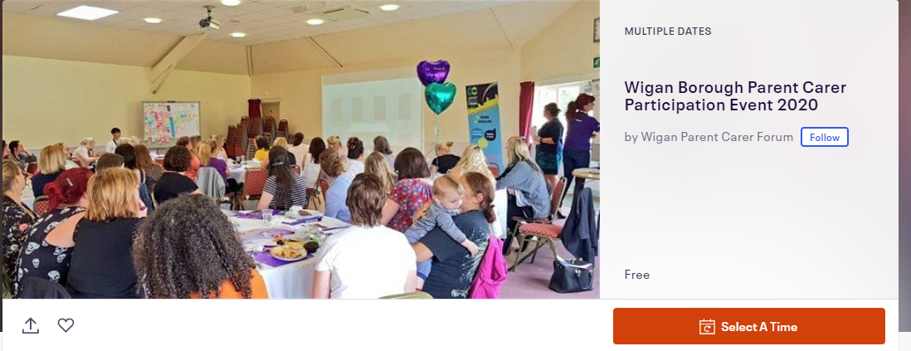

Wigan Council updates on transformation of services for children, young people and young adults those with Special Educational Needs and Disabilities (SEND) and their families

Come, listen and discuss Wigan Council’s You Said – We Did updates around SEND Transformation.

Thursday 30th January at Leigh Cricket Club WN7 3LH
10am – 1pm or
6pm – 8.30pm

Following on from various consultations, focus groups, surveys and events, working together with parent carers to transform SEND services in Wigan, Wigan Council would like to invite parent carers of children and young people with SEND aged 0-25 to hear updates and contribute to table top discussions on transformation of the following:

- Inclusion and support in mainstream
- SEND offer including EHC Pathway
- Provision for young people with autism or similar needs
- Sensory support
- Support for Parents
- Short breaks

Places must be booked for catering and refreshment purposes through Eventbrite http://bit.ly/PCParticipation2020Wigan

