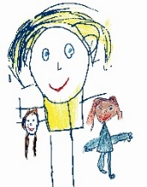

Helicopter Stories

Have a go at creating stories with your child.
Write down a beginning, middle and end (this can be very simple).
Then your family could be the characters and act out the story or maybe use teddy bears or anything that you would like as your characters to tell the story.
You create and show your story first then your child can see what to do. Then when it’s your child’s turn, write down what your child says, it could be as simple as;

- Once upon a time, there was a dog
- He went for a walk in the park
- After the park he went home


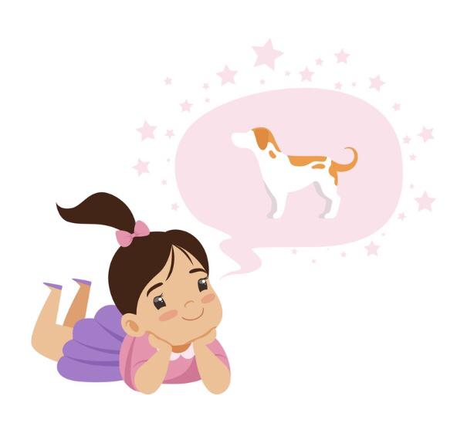

© Westfield Community School and Start Well Family Centre

