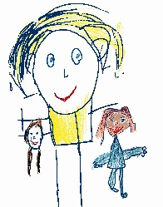
A Listening Walk

This can be done anywhere any time, you could just be nipping to the shop! Tell your child you’re going on a Listening walk and they must listen carefully for the sounds around them. When you hear something stop, ask them to be quiet and still. Take turns describing what you hear.

e.g birds “tweet tweet”
People “chatter chatter”
Wind “whoosh”
Horn “beep beep”


© Westfield Community School and Start Well Centre

