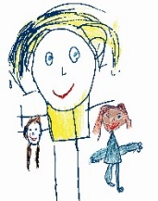

Small World

When playing with small world toys start by using simple language like ‘car’ ‘van’ ‘man’, then extend by saying ‘red car’ ‘big car’ ‘little car’ etc.

You can extend further by talking about:
- Size and quantity (big and little, more or less)
- Colour (ask your child to give you a red one etc)
- Sounds they make (beep, moo, brum brum)
- Counting (line them up and count, ask your child to give you two etc)

Observing your child giving them chance to think and respond.

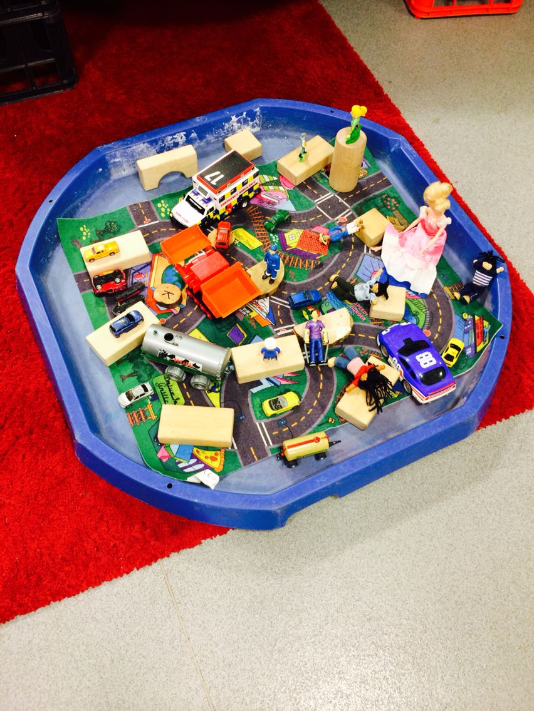

© Westfield Community School and Start Well Family Centre

