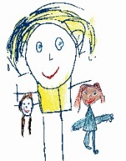

Moon Sand

Fun to make and even more fun to play with!

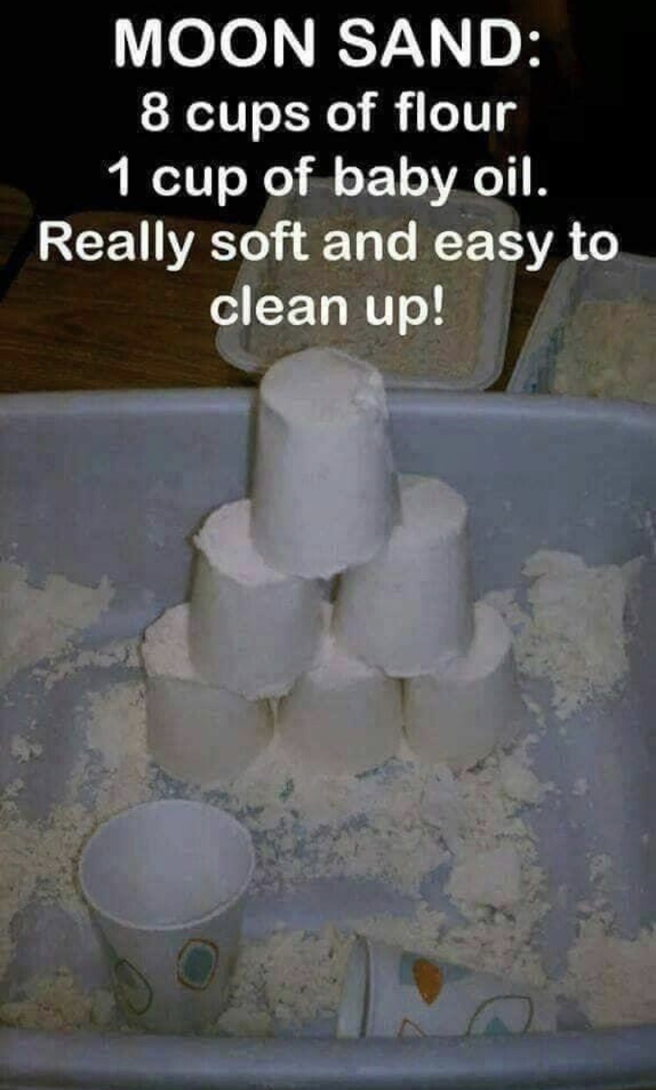

Remember to talk to your child about what they are doing … ask questions, encourage them to explain what they are making.

It’s good to talk!

© Westfield Community School and Start Well Family Centre

