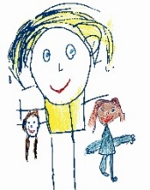

Pencil Control
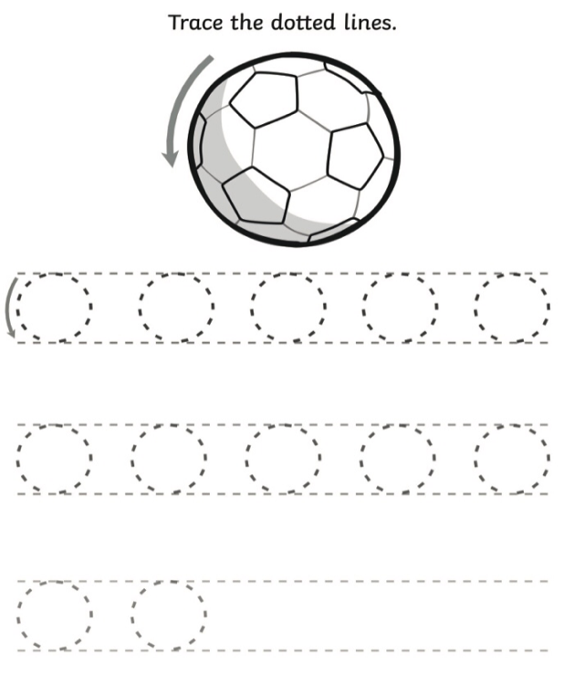
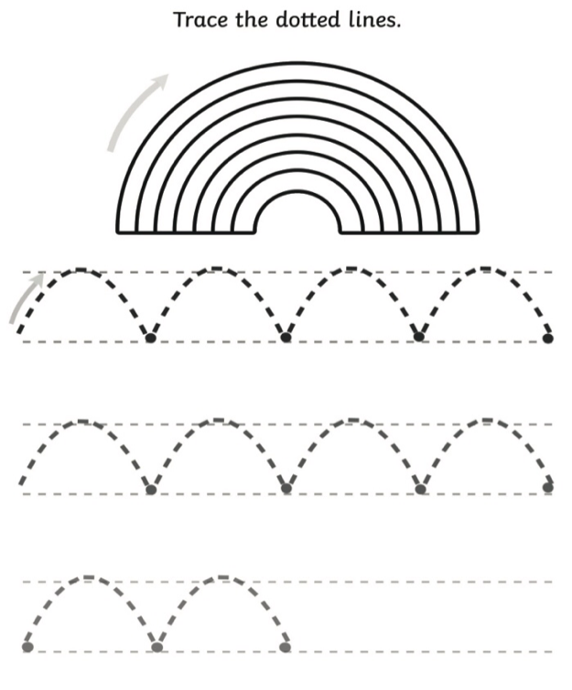
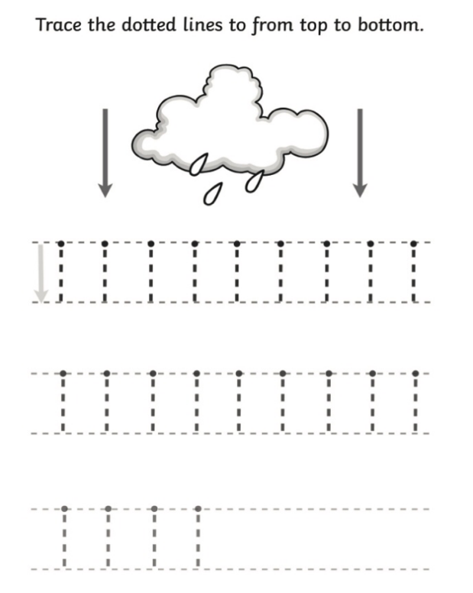
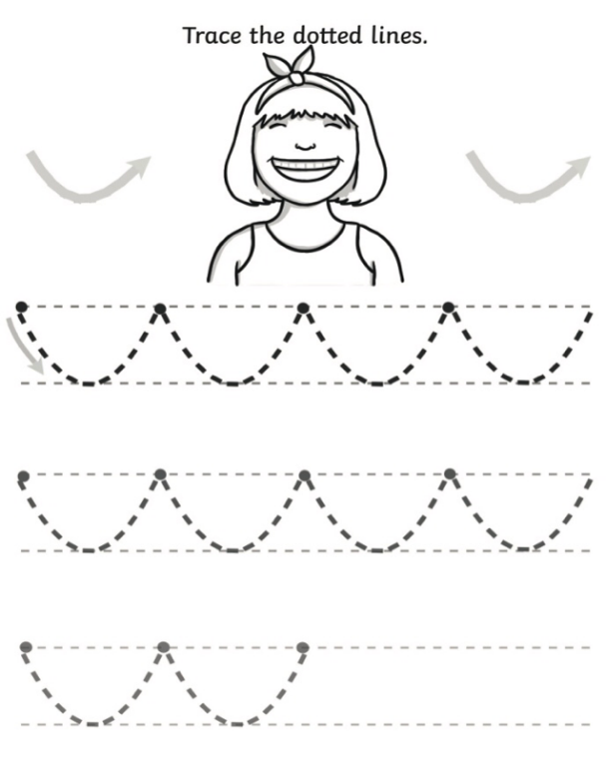
You can print these out getting your child to trace over the dotted lines. You could also create your own, use a light colour to create then get your child to trace over with a darker colour.
© Westfield Community School and Start Well Family Centre

