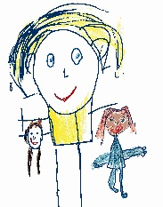
How to make Play-dough

Ingredients
2 cups of plain flour
1 cup of salt
1 cup of water
1 tablespoon of vegetable oil
Food colouring of your choice (optional)

Method
- Mix the flour and salt together
- Add water, oil and food colouring and mix together
- If it is too wet add a little more flour
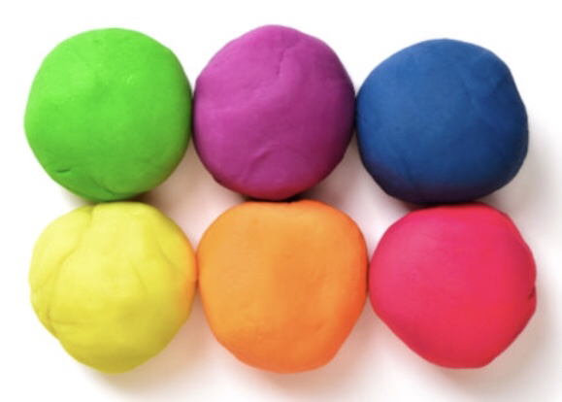
- Enjoy playing!!!!
REMEMBER: Talk to your child about what they are doing and what they have made. Use words like roll, squash, squish.
© Westfield Community School and Start Well Centre

