

Chocolate Goop

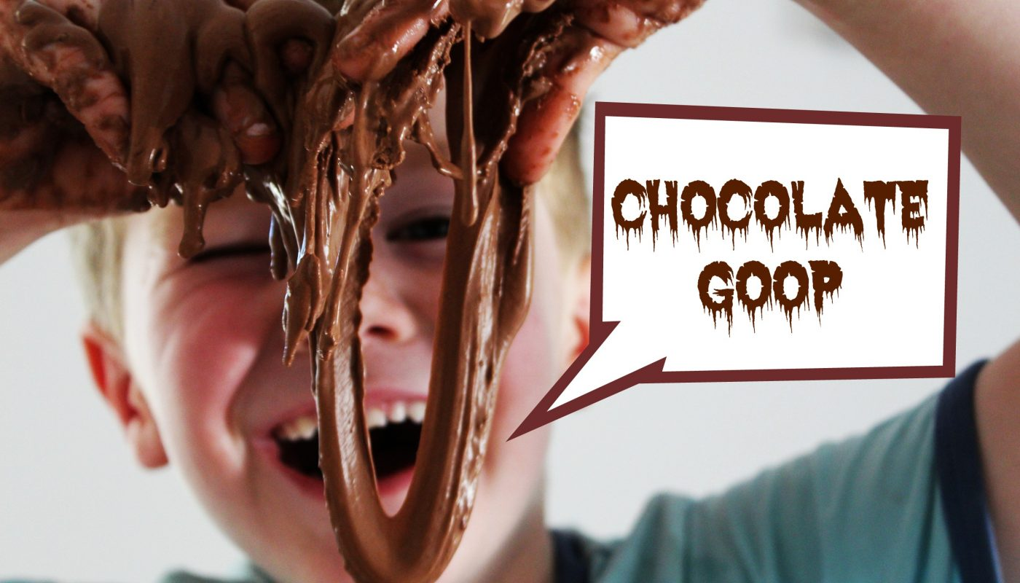

To make your own Chocolate Goop you will need:
600g Cornflour
4 tbs of cocoa powder
2.5 cups water
THAT’S IT!

Directions:
Pour your cornflour into a large bowl
Add your cocoa powder and stir well to combine.
Add the water and stir, stir, stir!
This stuff is truly amazing! It looks like a solid and when you pick it up, it starts to stay that way until it magically slimes down your fingers! Sooooo cool!

