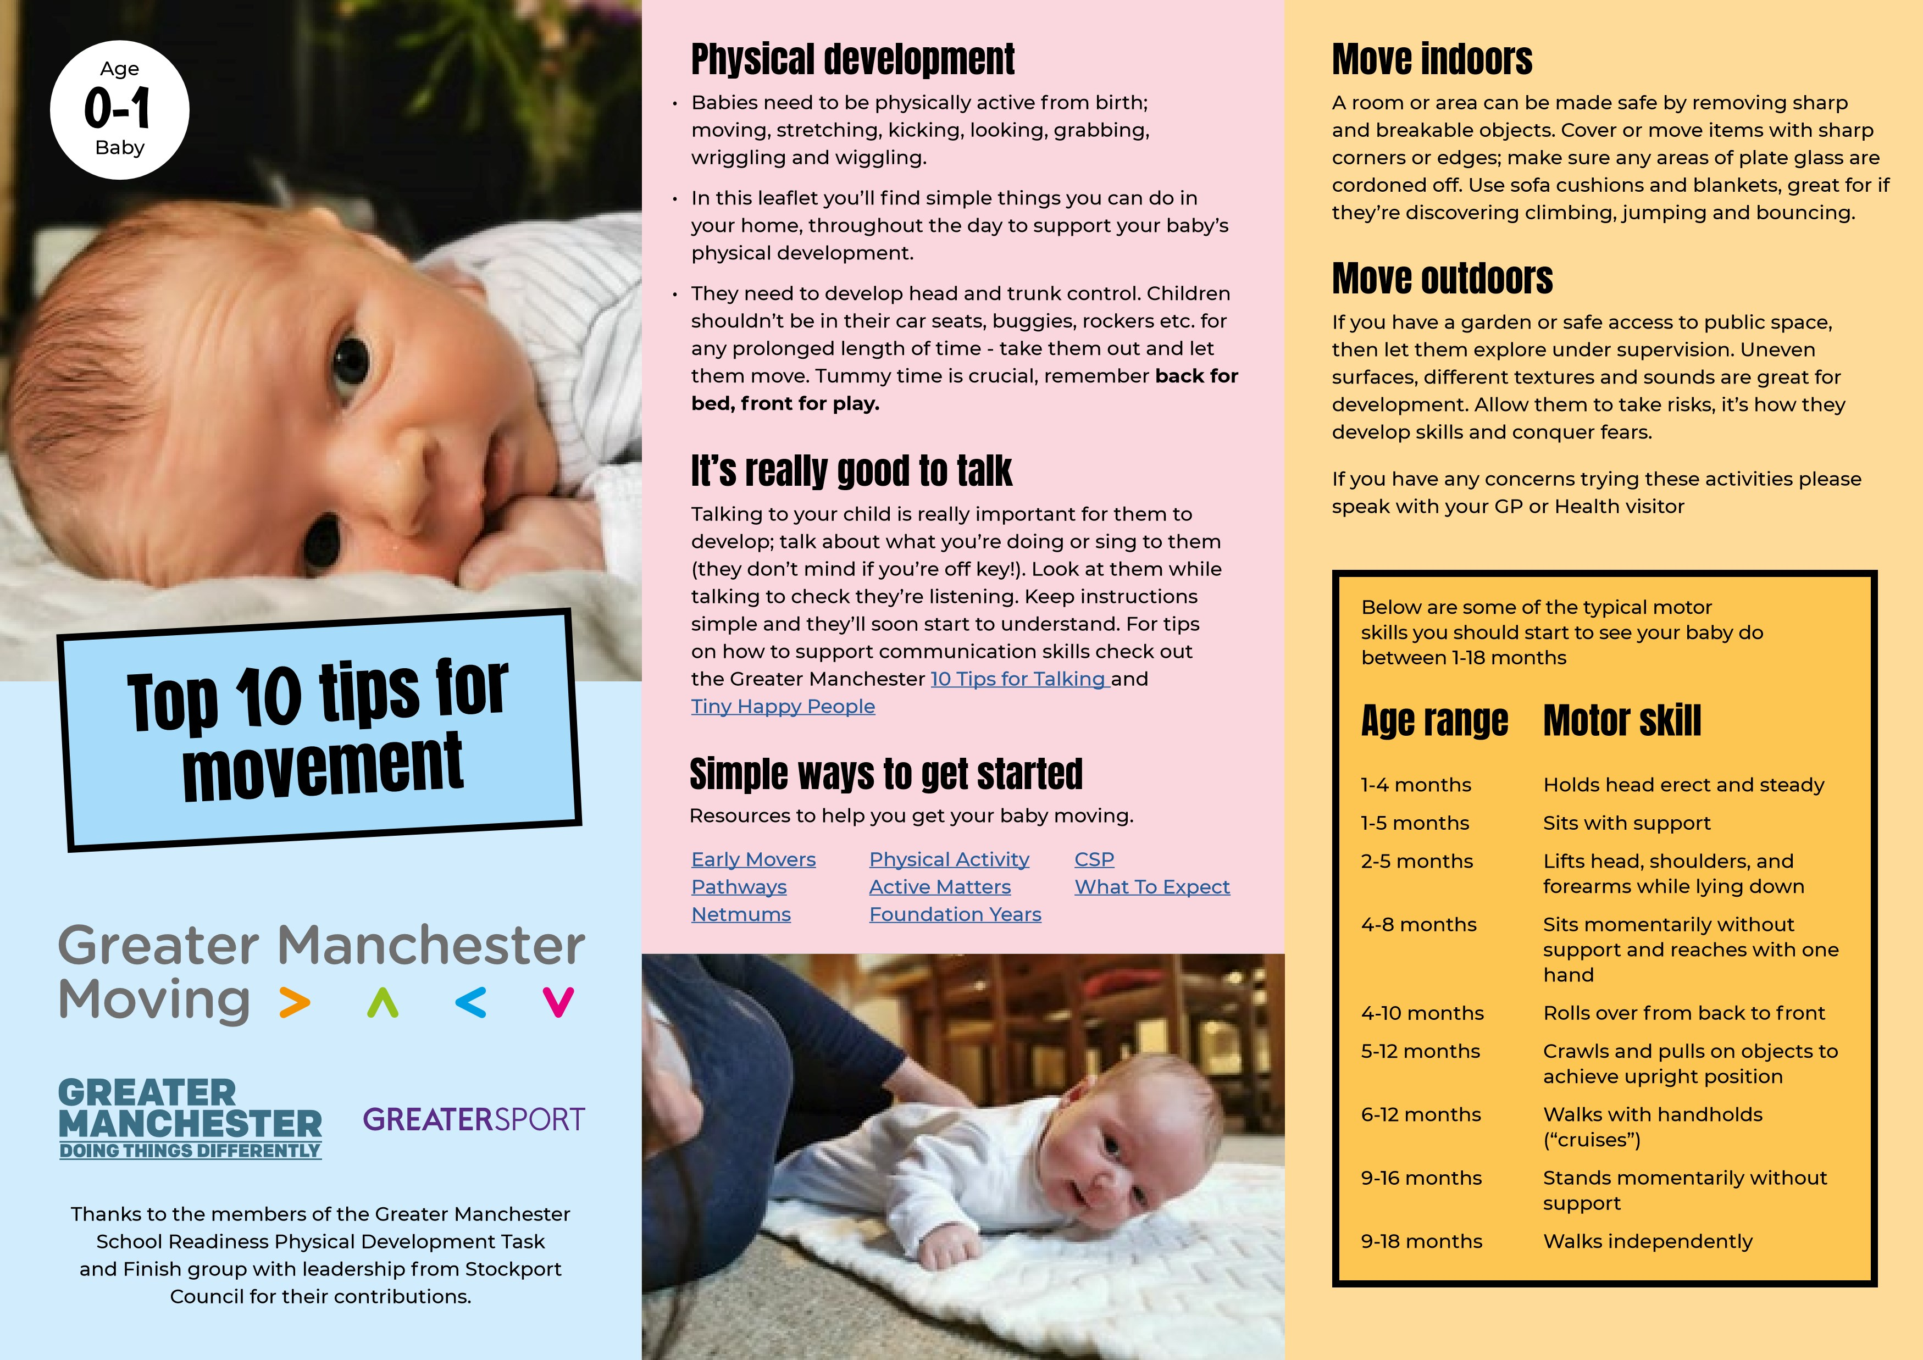
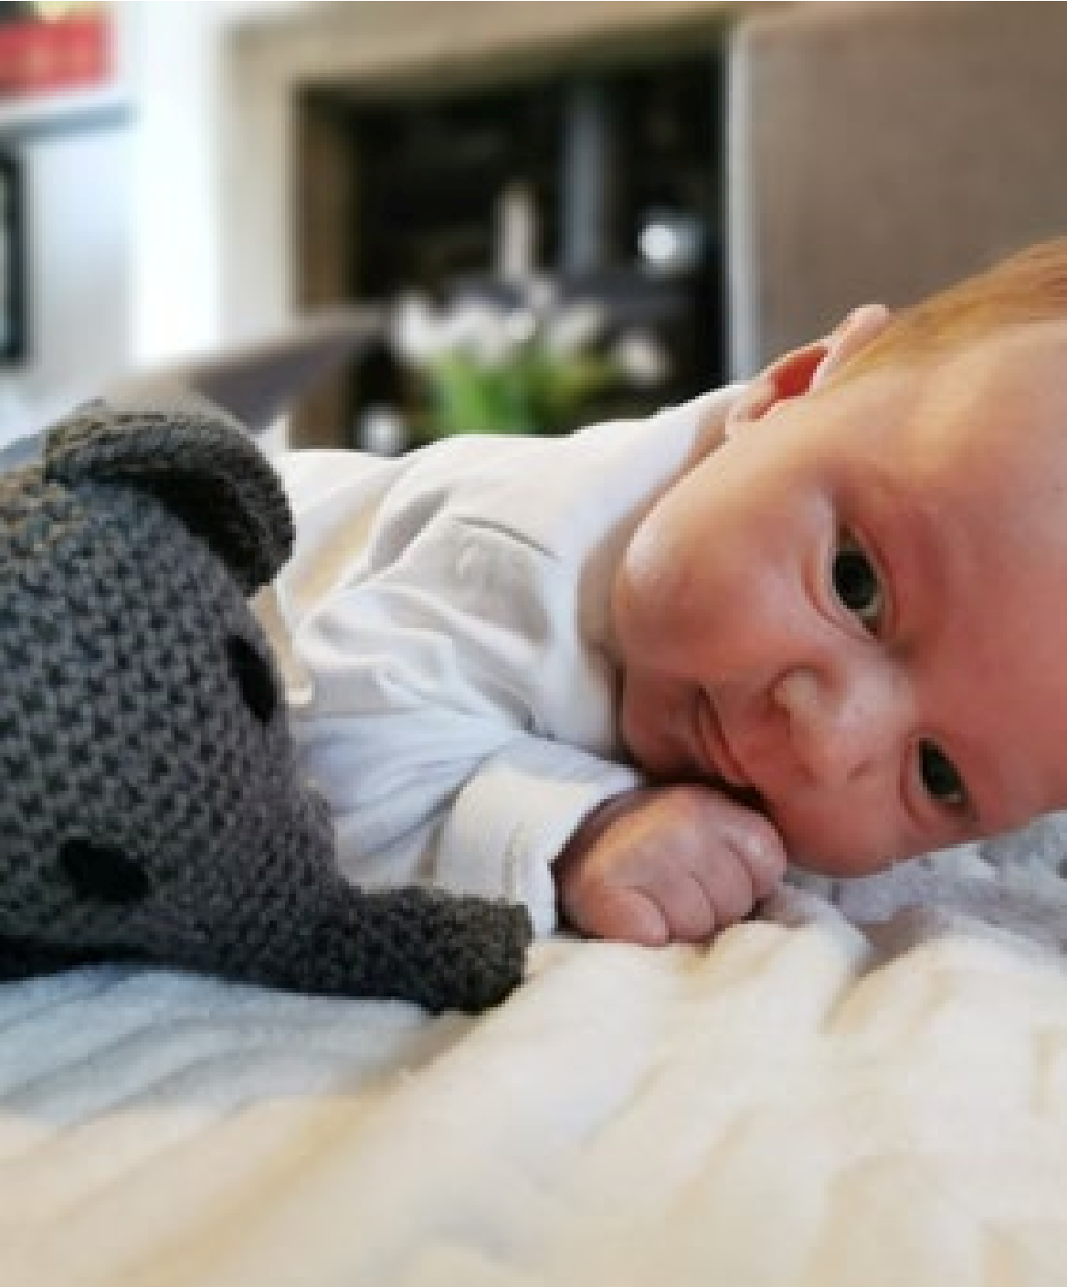
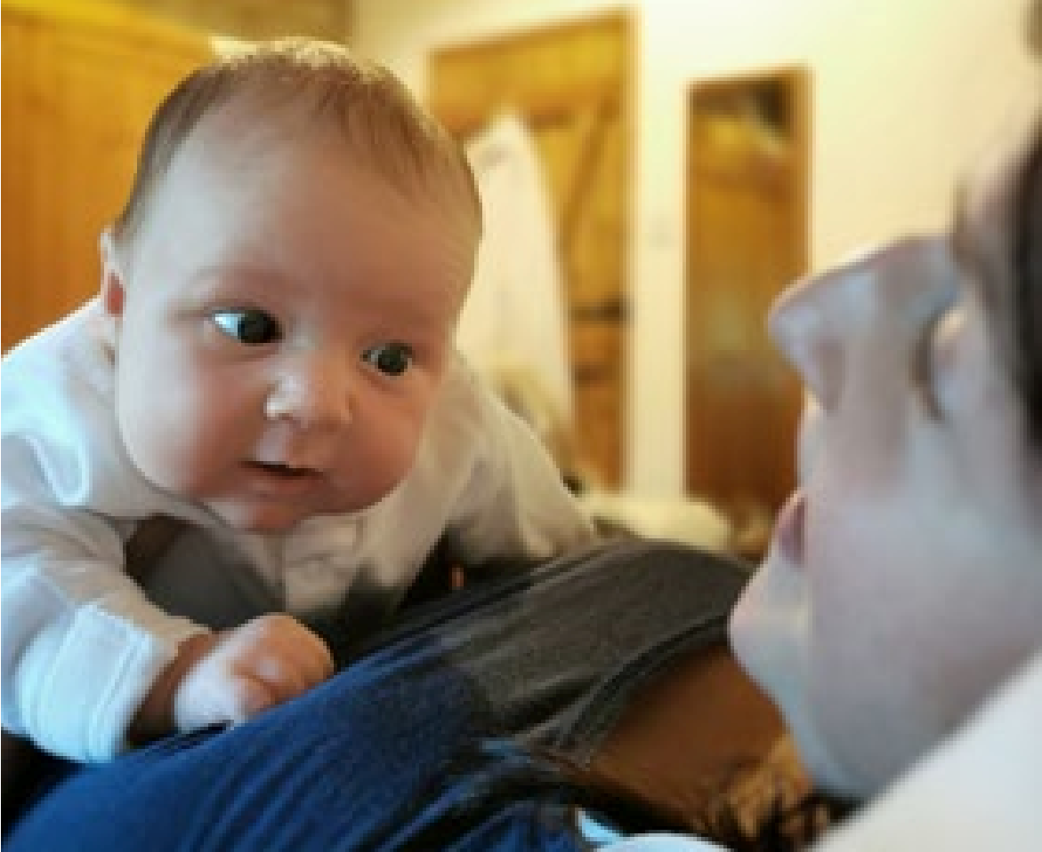

I love music and movement, hold me and move
around the living room with me or lie down and
balance me on you so we can move together.
When I’m on my tummy, put my favourite object
in front of me to encourage me to move. I’ll do it
eventually. Don’t worry if I don’t crawl, some of us can
go straight from shuffling to standing up.
Rolling helps me to develop my balance and
strength. Help me to roll from the hip and from
front to back and back to front.
Water’s really important to me, I spent 9 months in it!
Keep smiling and looking at me when I’m in the bath
and try to make it as fun as possible, with splashes and
playful noises.
Take me out of my cot, rocker or car seat for a
cuddle. I love to kick my feet and wiggle about.
Tickles are the best thing ever! You could even try to
give me a baby massage.

I like to explore and experiment, by myself and with your
help. If I’m near the sofa, let me try to pull myself up or
find things that I can reach out to and grab. When I’m
ready, I’ll start to cruise around holding your hands and
eventually take my first few steps.
I just need things to help me reach and grasp,
pull and push.
Hold an object in front of me and let me follow it with
my eyes. When I’m shuffling about, I’ll try and chase
a ball if you roll it away from me. Eventually I’ll learn
how to roll the ball, just like you.
Get down on my level, this helps me to engage
with you. Involve my senses in play; smell, touch,
taste, sight, listening.
I need tummy time to strengthen my muscles that I’ll
need to crawl. I might not like being on my tummy
and I might cry, but try it for short amounts of time. Or
try lying me on your tummy whilst you’re lying down.
Remember, back for bed, tummy for play.
Bubbles are a great way to get me to move my eyes,
I can follow them in lots of directions which will help
strengthen my eye muscles.
1
. Move with me
4
. Help me to crawl
7
. I love to roll around
. Make my bath time fun
5
. Take me out of my pram, high chair
8
and car seat for tickles and touches
6
. Let me explore
. I don’t need fancy toys
9
. Give me time to play. Show me how
10
to play. Support me in my play
. Put me on my tummy
2
3
. Give me something to look at
All activities can be adapted for those with
disabilities. Support your child to move as much as
possible (arms, legs, head). If in a wheelchair and
there’s room, spin on the spot and move around;
build up the energy in the room. Where movement is
not possible as suggested, aid them to touch and feel
the equipment to involve them in the activity.

