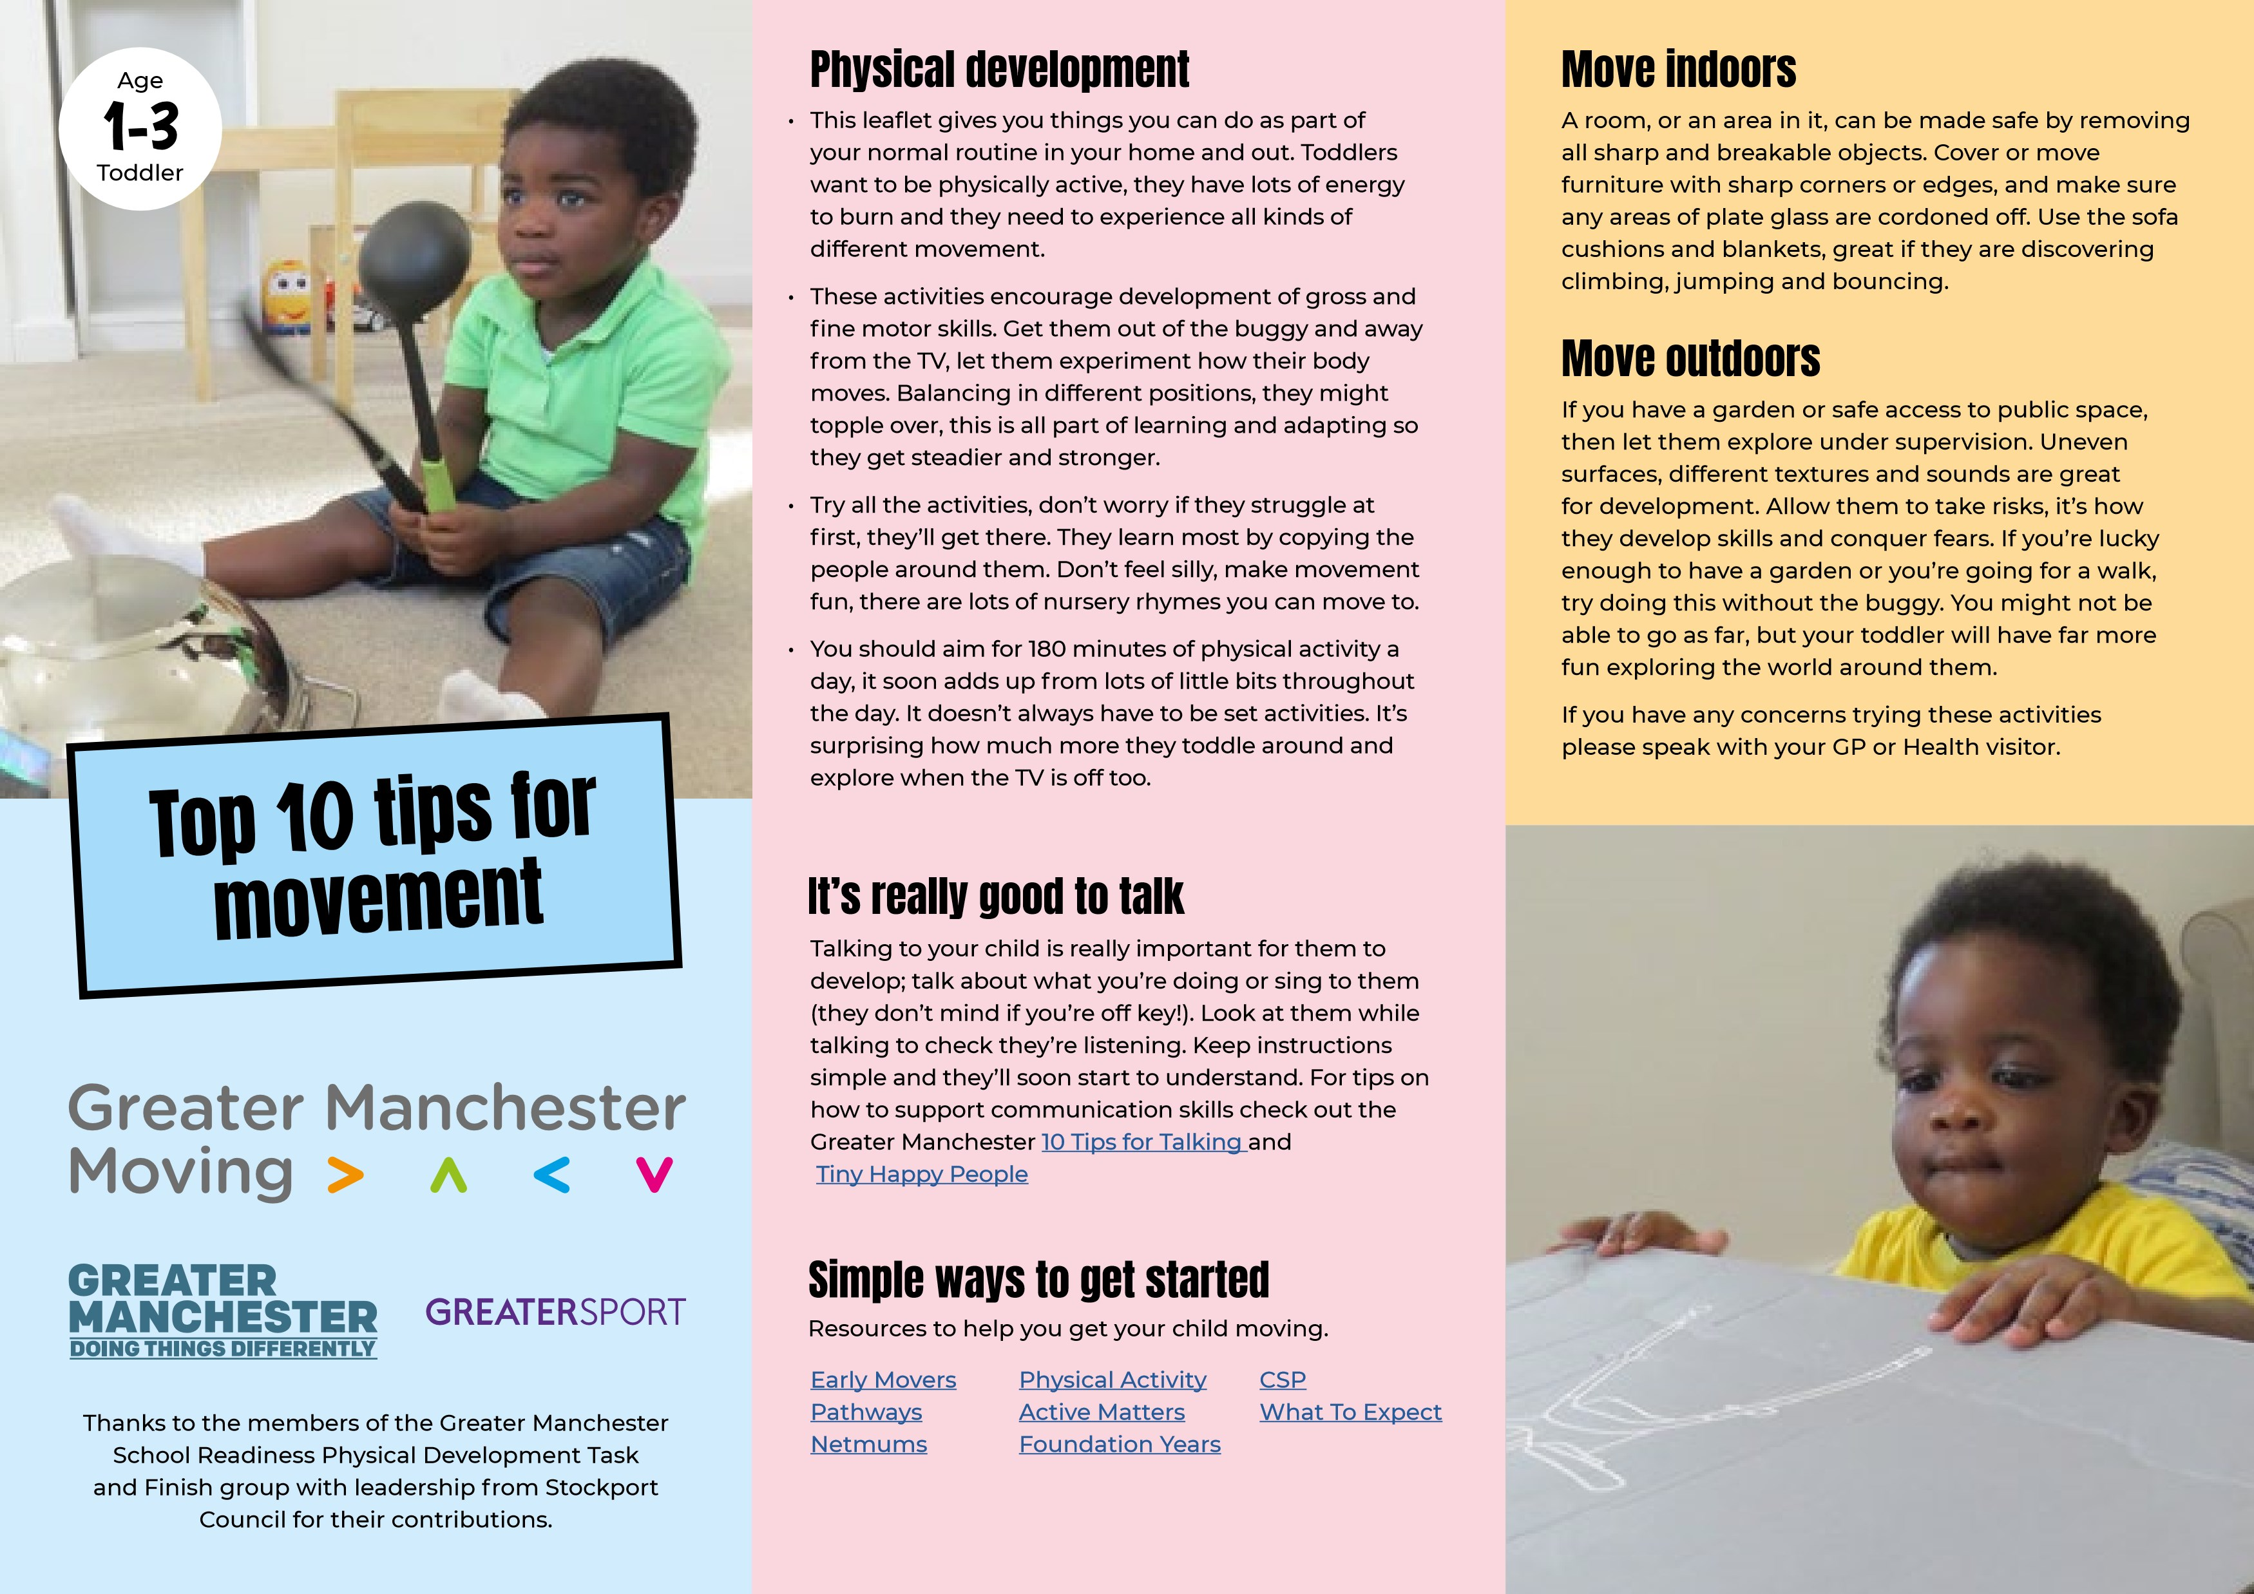

1. Move with me
I love music especially if I can move to it with you. Try different party games like musical statues (don’t worry if I don’t always freeze.) As I get older we could take it in turns to make up different moves.

2. Let me move as much as possible
I’m developing my coordination and growing stronger. Now I’m walking, add some more fun, like asking me to speed up, slow down, take big strides, tip toe, walk tall, walk small, stomp and jump too. See if I can go sideways and backwards. Bubbles are a great way to help me move by chasing, grabbing and kicking.

3. Give me time to play
Show me how to play. Support me in my play. Get down on my level, this helps me to engage with you. Involve my senses in play; smell, touch, taste, sight, listening.

4. Encourage me to move more when we are at home
I love going on adventures and the best bit is that I can explore, climb and crawl without even leaving the house. Grab a cardboard box so I can hide in it and peek out at you, we could even make a home-made den using bedsheets and cushions.

5. Balancing
Try making a balancing path for me to follow, or a tightrope for me to walk along with chalk or tape, see if I can do it without stepping off, make it shorter or longer, or send it in different directions.
6. Help me make my arms strong, this will help me learn to write.
Throwing different objects helps me master hand eye coordination and make my arms strong. Try balls, scarves, rolled up socks, a tea towel, scrunched up paper – anything safe and soft! Be creative, get me used to the object doing different things and moving in different ways, using different types of throwing like overarm and underarm.

7. I like to be barefoot, get me to take off my shoes
Let me explore different textures with my feet. I can do this inside or outside, find some large, low-sided plastic boxes, washing up bowls or baking trays, large enough to fit my feet in, fill each box with a different type of texture like water, scrunched up paper, sand, soil or rice and get me to walk through the different boxes.

8. Let me get messy
As long as I’m dressed sensibly, I’ll be able to move more independently. Let me make you a mud pie, fill buckets or empty tubs with different textures
e.g. porridge, dry rice, water or leaves. Ask me to fill the containers up with large spoons and get me to transfer the mixture from one to another, this helps my hand-eye coordination.

9. Help me to do things by myself
This could include helping with household tasks like tidying my room. How about making fun activities out of doing the washing or putting the pots away so it fits into your daily routine – if you show me what to do I will love to try and help.

10. Give me time to play outside
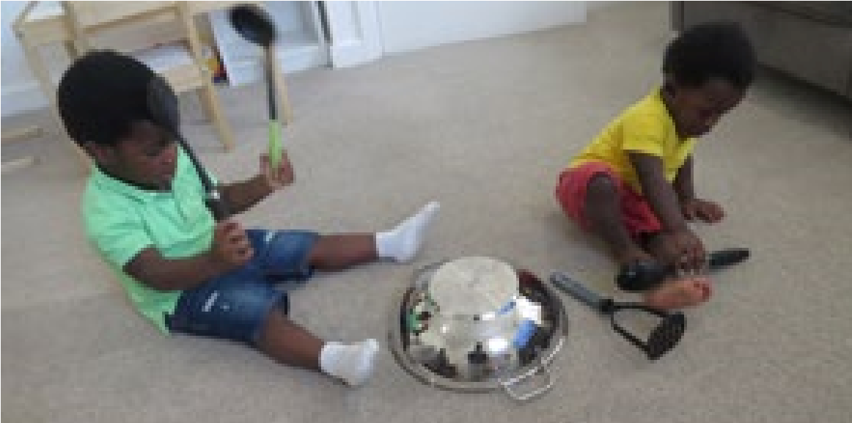
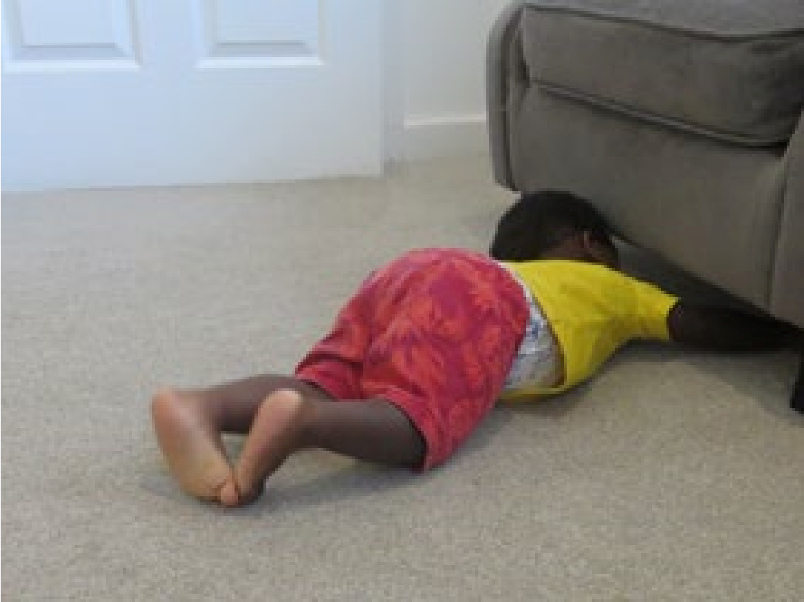
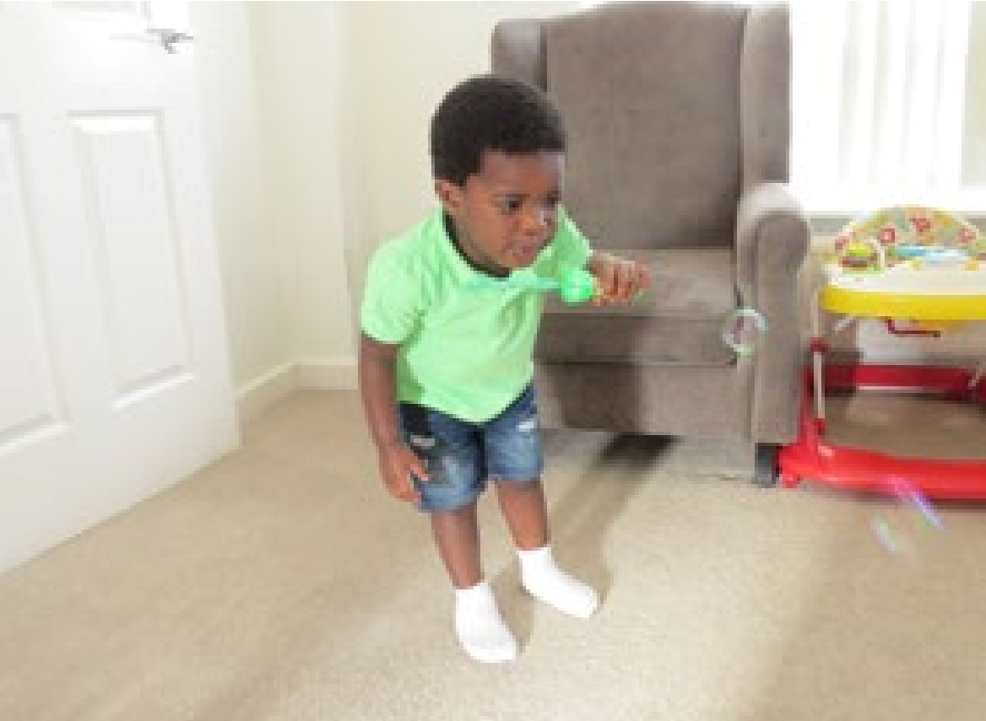
This will help me to be more active and learn about the natural environment. Let me walk, run and move on different textures and surfaces like grass and concrete. This will help build my balance and get me ready to deal with tricky tasks like climbing stairs. Any safe open space close by or a garden will do, we can have races, chase and pop bubbles and jump or step over the cracks in the pavements.
All activities can be adapted for those with disabilities. Support your child to move as much as possible (arms, legs, head). If in a wheelchair and there’s room, spin on the spot and move around; build up the energy in the room. Where movement is not possible as suggested, aid them to touch and feel the equipment to involve them in the activity.

