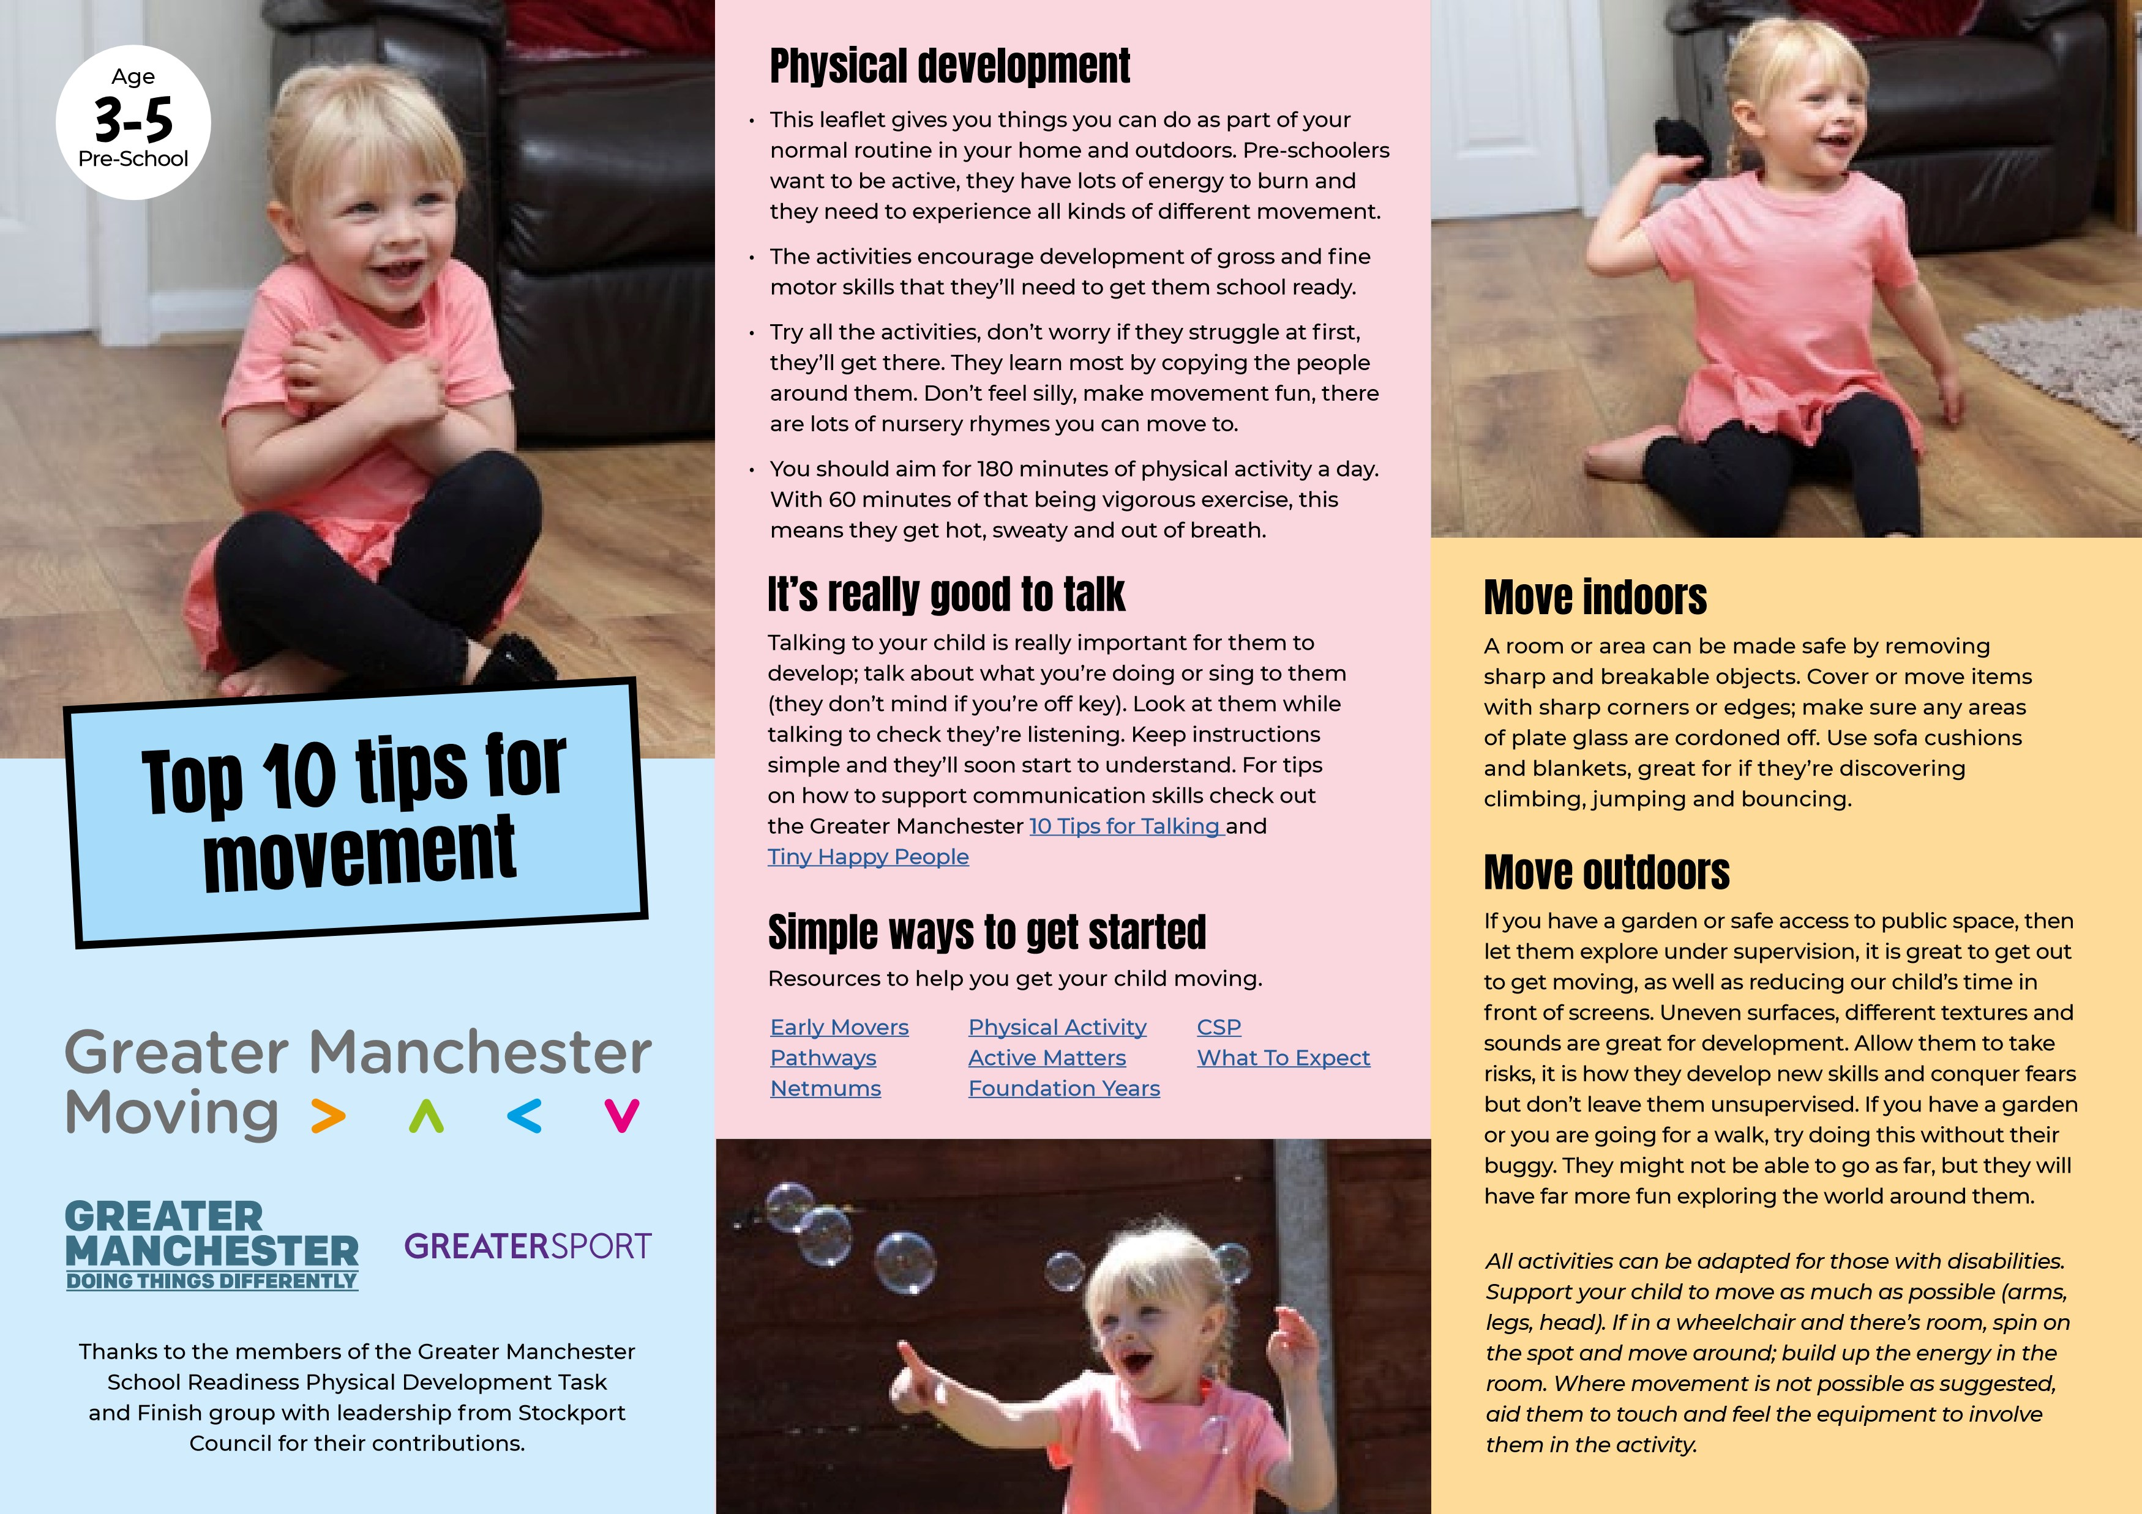

Move with me
I love music especially if I can move to it with you. Try different games like musical statues, we can take it in turns to make up poses or just make up a dance to my favourite song.

Challenge me
Now I’m walking, running and maybe jumping I like to be the best and the fastest. Set me challenges against the clock, or get me to make my own obstacle course using my favourite moves. I can go backwards, sideways, fast or slow, try jumping, hopping, skipping and balancing. I might struggle at first but I will master them if I keep trying!

Kick, strike and hit
Now I am a bit older I like to kick, hit and strike things to make them move. Give me different objects to kick with my feet and strike with my hands. Rolled up socks, balloons and scrunched up tea towels. A simple keep it up game using all my different body parts will help me develop my coordination.

Help me do things by myself
Let me have a go at making my bed, putting my socks and shoes on and putting my coat or jumper on. We can play games to help me practice this, like balancing on one foot or stretching up high to put my t-shirt on.

Encourage me to move more when we are at home
I love going on adventures and the best bit is that I can explore, climb and crawl without even leaving the house. Grab a cardboard box and I’ll come up with lots of ideas of how to use it or we could make a home-made den with bedsheets and cushions.

Both sides of my body
Help me use both sides of my body at the same time, this will help with my reading and writing. An easy way to get me to do this is with head, shoulders, knees and toes, or Simon Says and get me to copy your movements. Play a game to get me to pass objects from one side of my body to another; I can do this sitting down or standing up.

Let me take risks
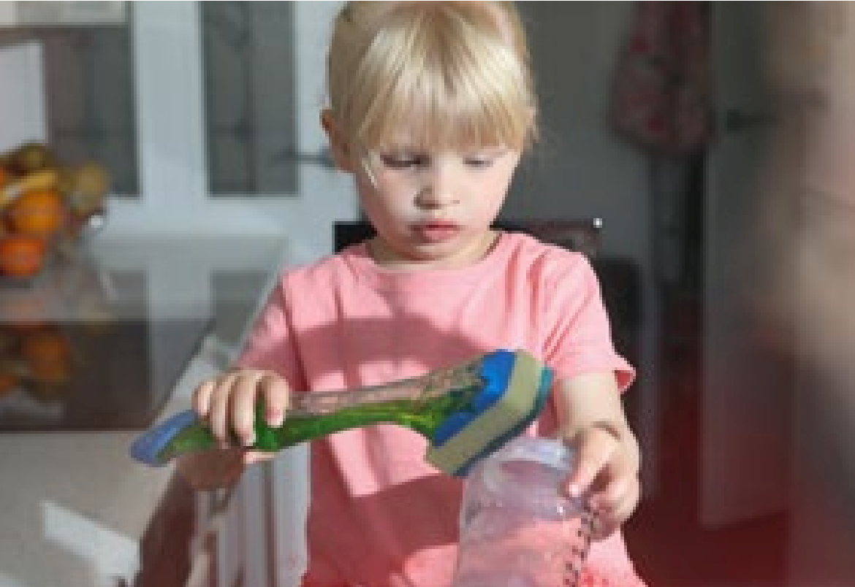
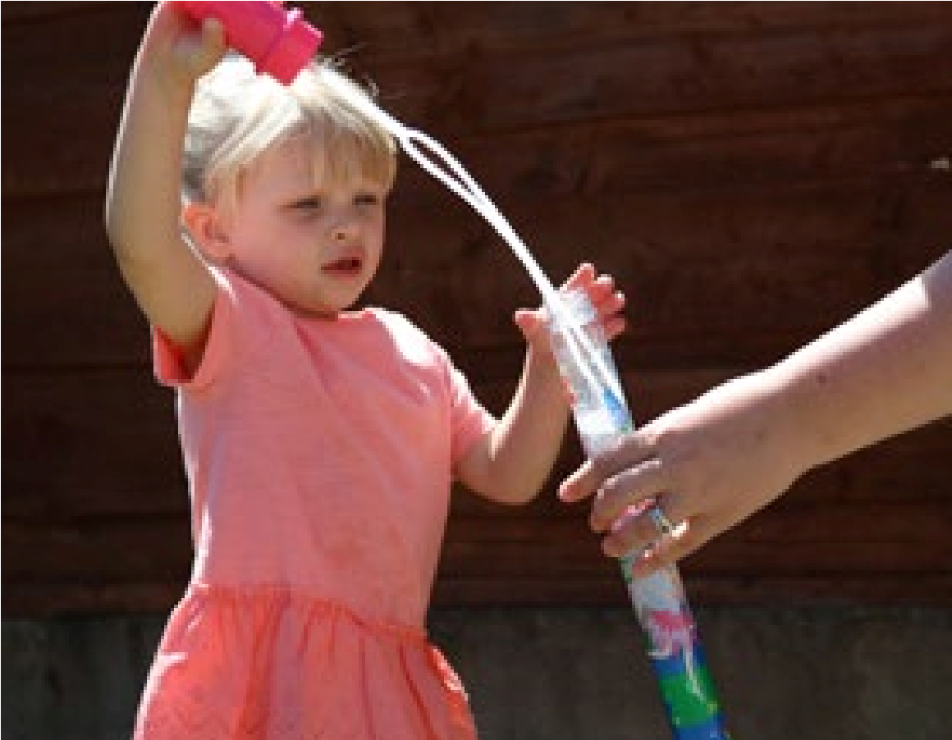
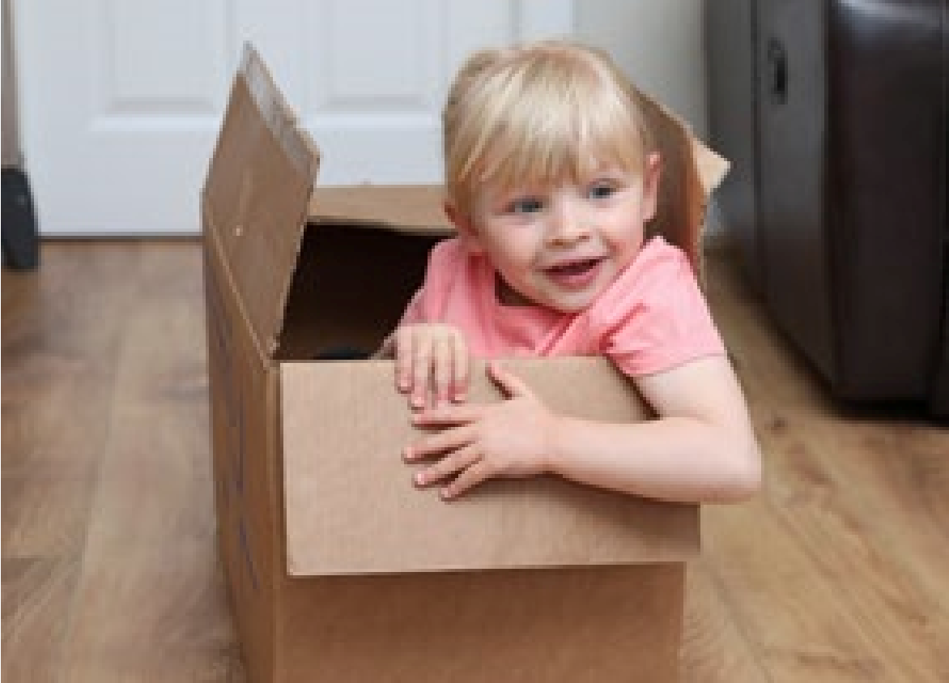
I’m getting braver when I’m moving, I may want to climb higher or run faster, this is okay as long as you keep an eye on me. Sometimes I’ll fall over or get it wrong but that’s okay, it’s how I’ll learn. Being outside will help me be more active and learn about the natural environment. Let me walk, run and move on different textures and surfaces like grass and concrete. Any safe open space close by or a garden will do, we can have races, chase and pop bubbles, jump or step over the cracks in the pavements. If you ask me ‘which way’ I’ll lead us on our adventure.

Balancing
Try making a balancing path for me to follow, or a tightrope for me to walk along with chalk or tape, see if I can do it without stepping off, make it shorter or longer, or send it in different directions.

Help me make my arms strong, this will help me learn to write
Throwing different objects helps me master hand eye coordination and make my arms strong. Try balls, scarves, rolled up socks, a tea towel, scrunched up paper – anything safe and soft! Be creative, get me used to the object doing different things and moving in different ways, using different types of throwing like overarm and underarm.

Help me sit in different positions
Sitting in the ‘W’ position, with each leg bent back to each side, can be common for me, but it will limit my trunk rotation and core strength. Encourage me to sit with my legs straight out in front of me with a straight back – I will copy you if you do it first. When I’m sat on a chair, make sure that my feet can touch the floor. This will make me feel stable and help me focus on what I’m doing. If I’m sat on a chair which is too high for my legs, then if possible put a ‘step’ under my feet like the ones I use when I’m toilet training.

