WESTFIELD LUNCH MENU SEPTEMBER 2026
WK | MONDAY | TUESDAY | WEDNESDAY | THURSDAY | FRIDAY
1 |     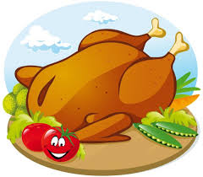    BBQ CHICKEN CALZONE PIZZA / CHEESE AND TOMATO CALZONE PIZZA OR JACKET POTATO  CHOICE OF SANDWICH |     MINCED BEEF PIE / TOMATO AND HERB PASTA BAKE OR JACKET POTATO  CHOICE OF SANDWICH | CHICKEN WITH VEGETABLES / QUORN WITH VEGETABLES OR JACKET POTATO    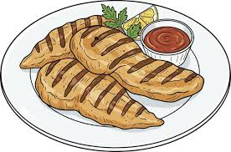  CHOICE OF SANDWICH | 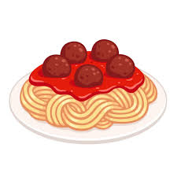  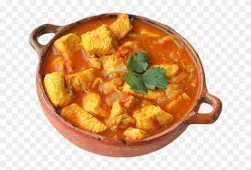    MEATBALLS IN TOMATO SAUCE / SWEET POTATO AND CHICKPEA CURRY OR JACKET POTATO  CHOICE OF SANDWICHSANDWICH |   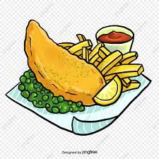    CHOICE OF SANDWICH  BATTERED FISH / CHEESE PANINI OR JACKET POTATO
2 | MEAT FEAST PIZZA / MARGHERITA PIZZA OR JACKET POTATO  CHOICE OF SANDWICH |   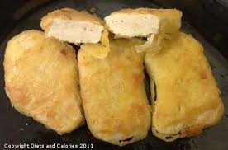  CHICKEN GOUJONS / CHEESE WHIRL OR JACKET POTATO  CHOICE OF SANDWICH |   CHOICE OF SANDWICH  BAKED SAUSAGES / QUORN SAUSAGE OR JACKET POTATO |   CHICKEN CURRY / MAC AND CHEESE OR JACKET POTATO  CHOICE OF SANDWICH | FISH FINGERS / QUORN MC SAUSAGE BURGER OR JACKET POTATO  CHOICE OF SANDWICH    

